ASSIGNMENT – 06 (DBMS LAB)

* **PROBLEM:**

Create a table Name_roll having Employee ID, First Name, Last Name, Salary, Date of Joining, Department Name, Designation attributes and Employee ID as Primary Key.

* **PROGRAM:**

create table employe_91(emp_id number(30),F_name varchar2(30),L_name varchar2(30),salary number(30),doj varchar2(30),dept_name varchar2(30),designation varchar2(30),primary key(emp_id));

* **OUTPUT:**

Table created.

* **PROGRAM:**

Describe employe_91;

* **OUTPUT:**

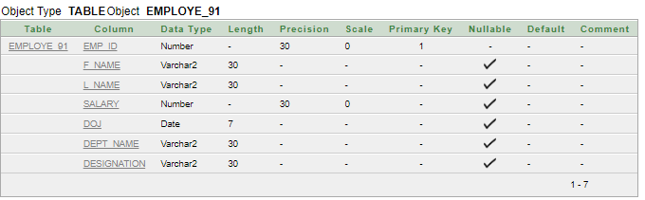

* **PROGRAM:**

begin

insert into employe_91 values('891','Ranjan','jana','30000','25/NOV/2000','CSE','HOD');

insert into employe_91 values('092','Sayan','Krmakar','32000','10/NOV/2001','PHARMACY','HOD');

insert into employe_91 values('093','sayan','Dutta','40000','30/OCT/2003','NURSING','ASSISTANT PROFESSOR');

insert into employe_91 values('094','Shilpa','Ojha','35000','10/JAN/2001','PHARMACY','DEAN');

insert into employe_91 values('095','sarolipi','Pal','26000','10/FEB/2003','NURSING','ASSISTANT PROFESSOR');

insert into employe_91 values('096','Sampad','Kar','24000','30/OCT/2001','CSE','HOD');

insert into employe_91 values('097','Sanjoy','Mannna','50000','25/NOV/2000','PHARMACY','ASSISTANT PROFESSOR');

insert into employe_91 values('098','Raja','Maity','30000','10/DEC/2000','CSE','HOD');

insert into employe_91 values('099','Swarup','Jana','20000','10/AUG/2001','PHARMACY','DEAN');

insert into employe_91 values('100','Bishwanath','Jana','25000','10/DEC/2000','CSE','ASSISTANT PROFESSOR');

insert into employe_91 values('101','Suvadip','Bera','26000','25/NOV/2003','CSE','HOD');

insert into employe_91 values('102','Furquan','Mazity','30000','10/JAN/2001','PHARMACY','HOD');

insert into employe_91 values('103','Soumyaip','Pal','35000','12/FEB/2001','NURSING','HOD');

insert into employe_91 values('104','Rahul','Debnath','40000','10/NOV/2000','PHARMACY','ASSISTANT PROFESSOR');

insert into employe_91 values('105','Sourav','Roy','15000','31/OCT/2003','CSE','HOD');

insert into employe_91 values('106','Bikra','Bera','21000','15/FEB/2001','PHARMACY','ASSISTANT PROFESSOR');

insert into employe_91 values('107','Prabin','Jha','30000','10/JUL/2000','PHARMACY','DEAN');

insert into employe_91 values('108','Prasun','Jana','32500','14/JAN/2003','NURSING','ASSISTANT PROFESSOR');

insert into employe_91 values('109','Palash','Bera','29000','16/NOV/2001','NURSING','HOD');

insert into employe_91 values('110','Guddu ','Mallik','21000','19/JAN/2000','PHARMACY','ASSISTANT PROFESSOR');

insert into employe_91 values('111','olivia ','Jana','20000','17/DEC/2001','NURSING','HOD');

insert into employe_91 values('112','Alfred','Novel','26000','13/NOV/2003','CSE','HOD');

insert into employe_91 values('113','Mamata ','Chowdhury','25000','10/OCT/2001','PHARMACY','ASSISTANT PROFESSOR');

insert into employe_91 values('114','Sweta ','Ojha','35000','25/JAN/2000','NURSING','HOD');

insert into employe_91 values('115','Sayak ','Panda','40000','10/JUN/2001','CSE','ASSISTANT PROFESSOR');

insert into employe_91 values('116','Bisa','Bhuima','45000','28/JUL/2000','CSE','HOD');

insert into employe_91 values('117','Md ','Azad','30000','10/DEC/2001','NURSING','HOD');

insert into employe_91 values('118','Diptesh ','Biswas','33000','10/AUG/2000','PHARMACY','ASSISTANT PROFESSOR');

insert into employe_91 values('119','kavaya','Singh','22000','10/NOV/2000','CSE','ASSISTANT PROFESSOR');

insert into employe_91 values('120','Rahul','Mazumdar','30000','15/OCT/2001','NURSING','DEAN');

end

* **OUTPUT:**

Statement processed.

* **OUTPUT:**

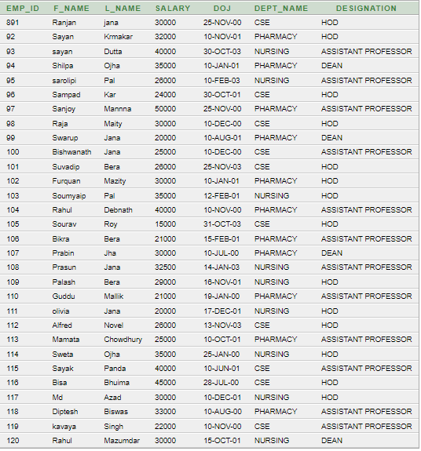

* **PROBLEM:**

Find those employee(f_name, dept_name, salary, designation) who earn more than 30000 and worked as a hod.

* **PROGRAM:**

select f_name,dept_name,salary,designation from employe_91 where salary>30000 and designation='HOD';

* **OUTPUT:**

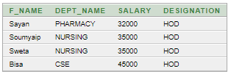

* **PROBLEM:**

Find those employee(f_name, dept_name, salary, designation) who earn more than 20000 and worked as a assistant professor.

* **PROGRAM:**

select f_name,l_name from employe_91 where salary>20000 and designation='ASSISTANT PROFESSOR';

* **OUTPUT:**

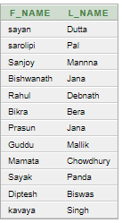

* **PROBLEM:**

Find those employee whose salary is between 20000 to 35000.

* **PROGRAM:**

select f_name,l_name from employe_91 where salary between 20000 and 35000;

* **OUTPUT:**

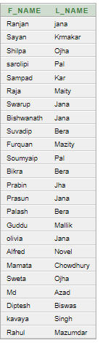

* **PROBLEM:**

Find the employeeʼs department name, DOJ and designation according to their DOJ in ascending order.

* **PROGRAM:**

select f_name,l_name,designation,dept_name,doj from employe_91 order by doj asc;

* **OUTPUT:**

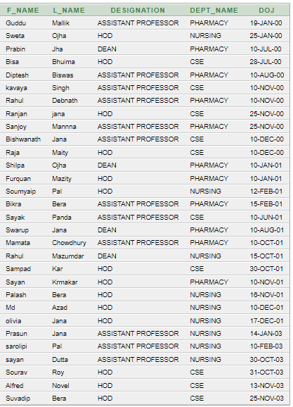

* **PROBLEM:**

Find the employeeʼs department name, DOJ and designation according to their DOJ in descending order.

* **PROGRAM:**

select f_name,l_name,designation,dept_name,doj from employe_91 order by doj desc;

* **OUTPUT:**

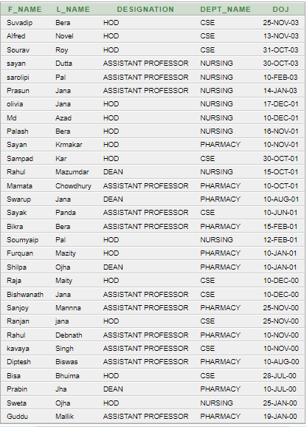

* **PROBLEM:**

Display F_name as Name and DOJ as Hire_Date.

* **PROGRAM:**

select F_name as Name, DOJ as Hire_Date from employe_91;

* **OUTPUT:**

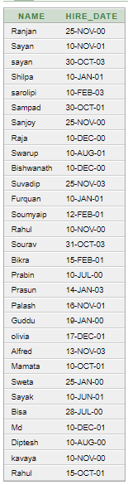

* **PROBLEM:**

Display F_name as Name and salary with 10000 increment.

* **PROGRAM:**

select F_name as Name, salary+10000 as salary from employe_91;

* **OUTPUT:**

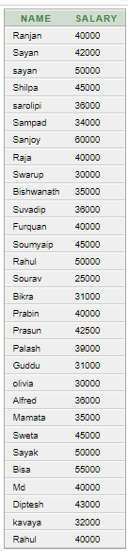

* **PROBLEM:**

Display F_name as Name and their Annual Salary as Annual_Salary.

* **PROGRAM:**

select F_name as Name, salary * 12 as Annual_Salary from employe_91;

* **OUTPUT:**

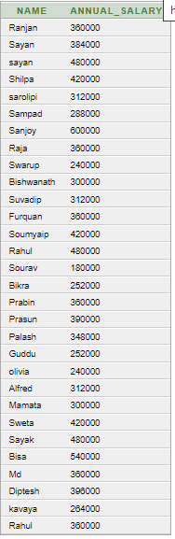

* **PROBLEM:**

Display their name and Annual Salary with 5000 increment.

* **PROGRAM:**

select F_name as Name, (salary * 12) + 5000 as Annual_Salary from employe_91;

* **OUTPUT:**

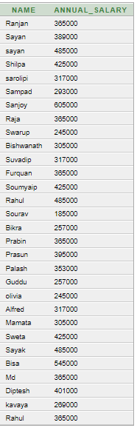

* **PROBLEM:**

Display the employee name whose salary is 80000 and DOJ is 9th October 2020.

* **PROGRAM:**

select F_name from employe_91 where salary = 30000 and DOJ = '25-NOV-2000';

* **OUTPUT:**

